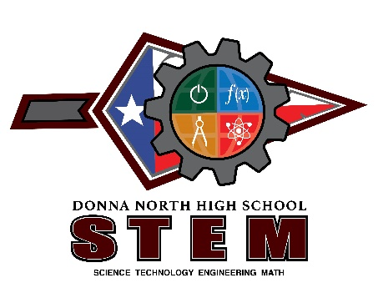

**Guest Speaker Series**

During the month of October 2021, Donna North High School T-STEM Academy hosted a guest speaker series for the T-STEM students. We partnered with local professionals in the STEM fields to have them come visit our campus and speak to our students. The speakers included Mr. Gregorio Arellano, BS Electrical Engineering (Donna ISD); Mr. Luis Madrigal, Mechanical Engineer (A&G Engineering); and Mr. Eduardo Lopez, Technical Lead Engineer (Boeing). These speakers shared their industry experiences first hand with our students. While each speaker had his own story to tell the overall message was that anything can be achieved through perseverance, hard work, and dedication.

Our ninth and tenth grade students attended the October 19th presentation by Mr. Gregorio Arellano.

Our eleventh grade students attended the October 26th presentation by Mr. Luis Madrigal.

Our twelfth grade students attended the November 2nd presentation by Mr. Eduardo Lopez.

**Space X Site Tour**

On December 3, 2021, Donna North High School T-STEM Academy partnered with Space X and took 45 students to tour their Brownsville, Texas facility. Students were able to tour the facility, see first-hand how space ships are put together, and see some of the latest technology in welding put to use. Students also had the opportunity to network with managers, recruiters, and welders at Space X to gain insight knowledge to one of today’s most technological advanced and cutting edge companies.

Students from both the eleventh and twelfth grades attended the Space X site tour.